**Final Year B.Tech. (CSE) – VII [ 2024-25]**

**6CS451: Cryptography and Network Security Lab (C&NS Lab)**

**Date: 05/08/2024**

**Assignment 2**

**PRN:** 21510017  **Name:** Onkar Anand Yemul

**1. Perform encryption and decryption using following transposition techniques**

**a. Rail fence**

**Ans:**

The Rail Fence Cipher is a type of transposition cipher where the plain text is written in a zigzag pattern across multiple "rails" (rows) and then read row by row to create the cipher text. Decryption involves reconstructing the zigzag pattern to retrieve the original message.

**Python code:**

def rail_fence_encrypt(plain_text, key):

    """

    Encrypt the plain text using the Rail Fence cipher.

    Parameters:

    plain_text (str): The input text to be encrypted.

    key (int): The number of rails (rows) for the Rail Fence cipher.

    Returns:

    str: The encrypted text.

    """

    # Create a list of strings to represent each rail

    rail = ['' for _ in range(key)]

    row, direction = 0, 1

    # Distribute the characters across the rails in a zigzag pattern

    for char in plain_text:

        rail[row] += char

        row += direction

        # Reverse direction when we reach the top or bottom rail

        if row == 0 or row == key - 1:

            direction *= -1

    # Concatenate all the rails to get the encrypted text

    return ''.join(rail)

def rail_fence_decrypt(cipher_text, key):

    """

    Decrypt the cipher text using the Rail Fence cipher.

    Parameters:

    cipher_text (str): The input text to be decrypted.

    key (int): The number of rails (rows) for the Rail Fence cipher.

    Returns:

    str: The decrypted text.

    """

    # Determine the length of each rail in the zigzag pattern

    pattern = [0] * len(cipher_text)

    row, direction = 0, 1

    for i in range(len(cipher_text)):

        pattern[i] = row

        row += direction

        # Reverse direction when we reach the top or bottom rail

        if row == 0 or row == key - 1:

            direction *= -1

    # Reconstruct the rails from the cipher text

    rail_lengths = [pattern.count(i) for i in range(key)]

    rail_chars = ['' for _ in range(key)]

    pos = 0

    for i in range(key):

        rail_chars[i] = cipher_text[pos:pos + rail_lengths[i]]

        pos += rail_lengths[i]

    # Reconstruct the original message by following the zigzag pattern

    result = []

    row_pointers = [0] * key

    for i in range(len(cipher_text)):

        result.append(rail_chars[pattern[i]][row_pointers[pattern[i]]])

        row_pointers[pattern[i]] += 1

    return ''.join(result)

def main():

    """

    The main function to run the menu-driven program.

    """

    while True:

        print("\nRail Fence Cipher Program")

        print("1. Encrypt")

        print("2. Decrypt")

        print("3. Exit")

        choice = input("Enter your choice: ")

        if choice == '1':

            plain_text = input("\nEnter the plain text: ").replace(" ", "")

            key = int(input("Enter the number of rails: "))

            encrypted_text = rail_fence_encrypt(plain_text, key)

            print(f"\nEncrypted Text: {encrypted_text}")

        elif choice == '2':

            cipher_text = input("\nEnter the encrypted text: ").replace(" ", "")

            key = int(input("Enter the number of rails: "))

            decrypted_text = rail_fence_decrypt(cipher_text, key)

            print(f"\nDecrypted Text: {decrypted_text}")

        elif choice == '3':

            print("Exiting the program.")

            break

        else:

            print("Invalid choice. Please try again.")

if __name__ == "__main__":

    main()

**Output:**

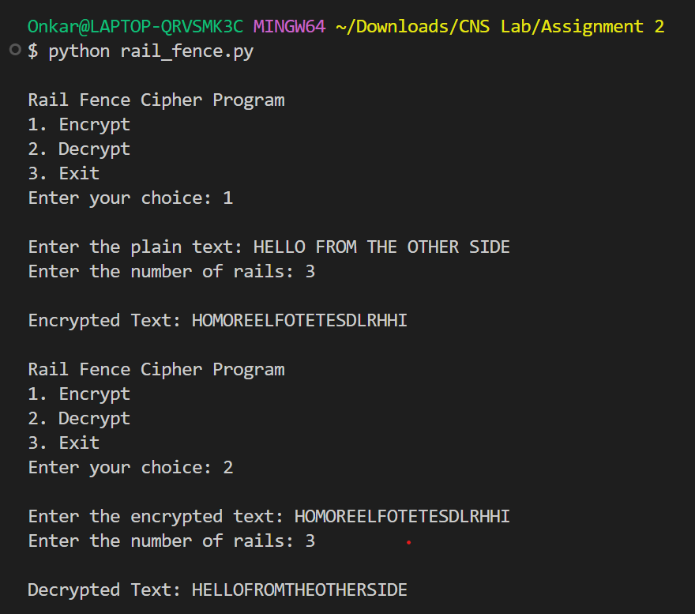

**Advantages:**

* **Simplicity**: Easy to understand and implement.
* **Low Computation**: Requires minimal computational resources for encryption and decryption.

**Disadvantages:**

* **Weak Security**: Very easy to break with simple analysis or known-plaintext attacks.
* **Pattern Recognition**: The regular zigzag pattern makes it susceptible to pattern recognition, which can be exploited to decode the message.

**b. row and Column Transformation**

**Ans:**

Row and column transformation is a type of transposition cipher where the message is written in a grid (matrix) and the order of rows and columns is changed according to a key.

**Row Transposition**: Encrypts text by writing it into rows of a grid, then permuting the columns according to a specific key.

**Column Transposition**: Encrypts text by writing it into columns of a grid, then permuting the rows according to a specific key.

**How It Works**:

1. **Write** the plaintext into a grid according to the number of rows or columns.
2. **Permute** the rows or columns based on the key.
3. **Read** off the text in the new order to get the ciphertext.

**Python code:**

import math

def create_matrix(text, key_len):

    """

    Create a matrix from the text with the specified number of columns (key length).

    """

    rows = math.ceil(len(text) / key_len)

    matrix = [['' for _ in range(key_len)] for _ in range(rows)]

    k = 0

    for i in range(rows):

        for j in range(key_len):

            if k < len(text):

                matrix[i][j] = text[k]

                k += 1

            else:

                matrix[i][j] = 'X'  # Padding with 'X' if the matrix is not full

    return matrix

def row_column_encrypt(plain_text, row_key, col_key):

    """

    Encrypt the plain text using row and column transformation.

    Parameters:

    plain_text (str): The input text to be encrypted.

    row_key (list): The key to rearrange rows.

    col_key (list): The key to rearrange columns.

    Returns:

    str: The encrypted text.

    """

    plain_text = plain_text.replace(" ", "")

    key_len = len(col_key)

    # Create the matrix from the plain text

    matrix = create_matrix(plain_text, key_len)

    # Apply the row key

    row_matrix = [matrix[i] for i in row_key]

    # Apply the column key

    encrypted_text = ""

    for row in row_matrix:

        encrypted_row = [row[j] for j in col_key]

        encrypted_text += ''.join(encrypted_row)

    return encrypted_text

def row_column_decrypt(cipher_text, row_key, col_key):

    """

    Decrypt the cipher text using row and column transformation.

    Parameters:

    cipher_text (str): The input text to be decrypted.

    row_key (list): The key to rearrange rows.

    col_key (list): The key to rearrange columns.

    Returns:

    str: The decrypted text.

    """

    key_len = len(col_key)

    rows = len(cipher_text) // key_len

    # Create the matrix to store the rearranged cipher text

    matrix = [['' for _ in range(key_len)] for _ in range(rows)]

    k = 0

    # Arrange the cipher text in the matrix based on the column key

    for i in range(len(row_key)):

        for j in col_key:

            matrix[row_key[i]][j] = cipher_text[k]

            k += 1

    # Read the decrypted text row by row

    decrypted_text = ""

    for i in range(rows):

        decrypted_text += ''.join(matrix[i])

    return decrypted_text

def main():

    """

    The main function to run the menu-driven program.

    """

    while True:

        print("\nRow and Column Transformation Cipher Program")

        print("1. Encrypt")

        print("2. Decrypt")

        print("3. Exit")

        choice = input("Enter your choice: ")

        if choice == '1':

            plain_text = input("\nEnter the plain text: ")

            row_key = list(map(int, input("Enter the row key as a sequence of numbers (e.g., 2 0 1): ").split()))

            col_key = list(map(int, input("Enter the column key as a sequence of numbers (e.g., 1 0 2): ").split()))

            encrypted_text = row_column_encrypt(plain_text, row_key, col_key)

            print(f"\nEncrypted Text: {encrypted_text}")

        elif choice == '2':

            cipher_text = input("\nEnter the encrypted text: ")

            row_key = list(map(int, input("Enter the row key as a sequence of numbers (e.g., 2 0 1): ").split()))

            col_key = list(map(int, input("Enter the column key as a sequence of numbers (e.g., 1 0 2): ").split()))

            decrypted_text = row_column_decrypt(cipher_text, row_key, col_key)

            print(f"\nDecrypted Text: {decrypted_text}")

        elif choice == '3':

            print("Exiting the program.")

            break

        else:

            print("Invalid choice. Please try again.")

if __name__ == "__main__":

    main()

**Output:**

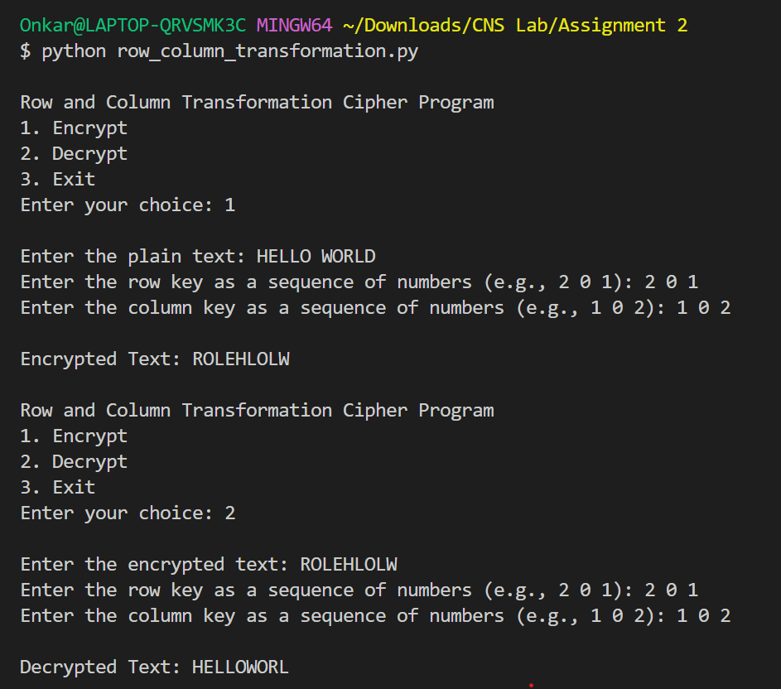

**Advantages**:

* **Increased Security**: More complex than simple transpositions.
* **Flexibility**: Key-based rearrangement can add security.

**Disadvantages**:

* **Complexity**: Can be more complex to implement and manage compared to simple ciphers.
* **Pattern Recognition**: Still susceptible to pattern analysis if not combined with other encryption methods.